Survey of Names of Sulawesi Mammals
2 July 2015 – downloaded from http://sulang.org/resources/survey-instruments#mammals
This survey consists of three parts. With access to an electronic lexical database, Part I can be completed in about twenty minutes. Parts II and III are optional, although any information you could supply under part II would be greatly appreciated.
Return the completed survey to Alastair Macdonald <Alastair dot Macdonald at ed dot ac dot uk> with cc: to Kristin Leus <kristin at cbsgeurope dot eu> and David Mead <david at sulang dot org>. Before returning the survey, please rename the file to include the language you are reporting about, e.g. “Sulawesi Mammals Survey (Kulisusu).doc”
Part I: Basic Terms
Please complete the requested metadata section, then fill in as many items for which you know the term in the local language. Use whatever orthographic conventions are usual for the language.
When we ask about male, female and young of a species, please report if this is a specific lexeme (as in English boar, sow, piglet, buck, doe, fawn), but please also report if this is a compound or phrase (e.g. ‘pig + male’, ‘pig + female’, ‘child + pig’). Be careful to report accurately. A number of Sulawesi languages have different terms for male and female of humans versus male and female of animals, but some languages may have terms that are more specific, e.g. male (specifically of bovines), female (specifically of bovines).
If any of your responses in Part I require an annotation, you may do so at the end of the table by keying it to the number given in the leftmost column. Alternatively you may add your own column for annotations, or delete our annotations and use that column. Please do not delete (or add) any rows to Part I, even if you are leaving a response blank.
As you fill out this questionnaire, please be alert to the possibility that local people may have knowledge of animals which have yet to be described scientifically, or at least not described for that locality. I (Alastair) anticipate that these reports may come from mountainous regions of Sulawesi where people may no longer live and/or hunt so frequently. It is conceivable that one (or more) not-yet-described marsupials may be locally known, or for there to be stories of ‘something’ being up there. It is likely not to be common knowledge, but awareness specific to one or two hunters. These fellows may be old, or quite young, in my experience.
Images are Public Domain except as otherwise noted. In some cases hyperlinks have been provided to additional images.

1 | survey respondent |  | Person filling out the survey.
2 | reference |  | If terms reported below have been taken from a published work (e.g. a dictionary), please give a bibliographic citation. If the source is a set of personally held field notes or an unpublished lexical database, please supply the collector’s name (can be the same as above).
3 | island |  | For most ‘Sulawesi’ but a few of you will differ, e.g. Talaud Archipelago, Sangir Archipelago, Muna, Buton, Togian Islands, Sula Islands, Buru.
4 | province
5 | language
6 | ISO 639-3 |  | Three letter ISO 639-3 (Ethnologue) code assigned to this language.
7 | dialect |  | If applicable.
8 | man, male  laki-laki |  | The term for male of humans. Opposite of female.
9 | woman, female  perempuan |  | The term for female of humans. Opposite of male.
10 | child (human)  anak |  | Opposite of parent.
11 | male (of animal)  jantan |  | The most generic / general term that the language possesses for male of animals. It may be the same as the response to 8, but in a number of Sulawesi languages it will be different.
12 | female (of animal)  betina |  | The most generic / general term that the language possesses for female of animals. It may be the same as the response to 9, but in a number of Sulawesi languages it will be different.
13 | anoa  anoa |  | Anoa spp.  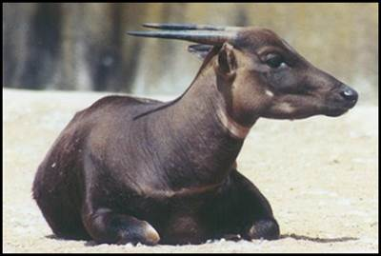  © 1999 Brent Huffman, www.ultimateungulate.com. Used with permission.  The taxonomic status and distribution of the two putative species, the lowland anoa A. depressicornis and the mountain anoa A. quarlesi, have been much debated. If the people who speak this language distinguish between different types of anoa, please add an annotation here or explain below under Part II.  More images: http://www.arkive.org/mountain-anoa/bubalus-quarlesi/  http://www.arkive.org/lowland-anoa/bubalus-depressicornis/
14 | male anoa
15 | female anoa |  | If the language has terms for a pregnant anoa and/or a lactating anoa, please add an annotation here or explain under Part II.
16 | young anoa
17 | babirusa  babi rusa |  | Babyrousa babyrussa.  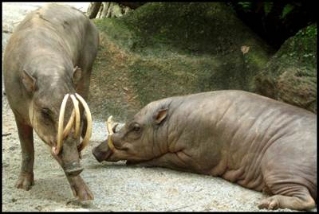  © 2006 Terence Ong. CC BY 2.5 Generic.  More images: http://www.arkive.org/sulawesi-babirusa/babyrousa-celebensis/
18 | male babirusa
19 | female babirusa |  | If the language has terms for a pregnant babirusa and/or a lactating babirusa, please add an annotation here or explain under Part II.
20 | babirusa piglet |  | If the language has terms for adolescent males according to the length of the upper canines, please add an annotation here or explain under Part II.
21 | pig/swine  babi |  | If the language has distinct terms for domestic pigs versus wild pigs, report these terms instead on lines 25 and 30, and skip lines 21–24.
22 | male pig, boar
23 | female pig, sow
24 | piglet
25 | wild pig  babi hutan |  | For the record, Sulawesi is home to two species of wild pigs. The Sulawesi warty pig, Sus celebensis (image below, left, also young male, center) occurs wild on Sulawesi, Timor, Flores, Halmahera and Simuleue, and as a domesticate on Roti and Timor. Feral populations of the Eurasian pig, Sus scrofa (below, right), occur throughout Indonesia. Males of the two species are distinctive, females less so.  .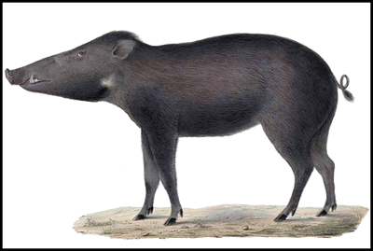 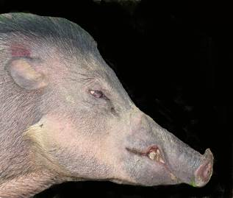 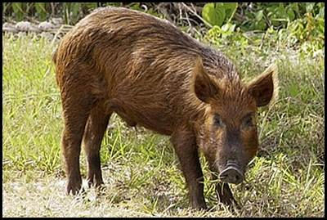  center image: © Alastair Macdonald  More images: http://www.arkive.org/wild-boar/sus-scrofa/
26 | male wild pig |  | Male Sulawesi warty pigs have three pairs of warts on their faces and the feral pigs do not. The warts situated just in front of the eyes are the largest. The hair on the forehead of the Sulawesi warty males is also distinctly ‘punk’.
27 | female wild pig |  | There is little to indicate the difference between S. celebensis and S. scrofa females. My (Alastair’s) impression is that the Sulawesi warty female will probably be somewhat smaller and more shy.
28 | wild piglet
29 | adolescent wild pig
30 | domestic pig  babi ternak |  | One of the ways that local people near the coast keep their pigs is often fairly unconfined, and so there is the opportunity for them to mate with endemic pigs (Sus celebensis). The cross-bred youngsters will be relatively easily identified as such and may be given their own name (e.g. horse x donkey = mule).
31 | male domestic pig
32 | female domestic pig
33 | domestic piglet
34 | water buffalo, carabao  kerbauw |  | Bubalus bubalis.  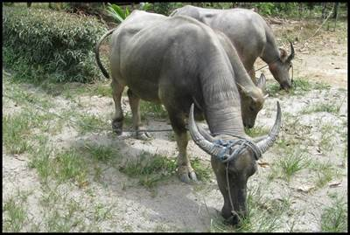
35 | male buffalo
36 | female buffalo |  | If the language has terms for a pregnant buffalo and/or a lactating buffalo, please add an annotation here or explain under Part II.
37 | buffalo calf
38 | buffalo adolescent
39 | cattle  sapi |  | Some Sulawesi peoples traditionally raised Bali cattle (Bos javanicus), a small type with white legs and white rump, and males with thick horns joined across the forehead by a cornified zone. Considered inferior to the zebu or Indian humped cattle (Bos taurus indicus), it has now been mostly replaced by it.  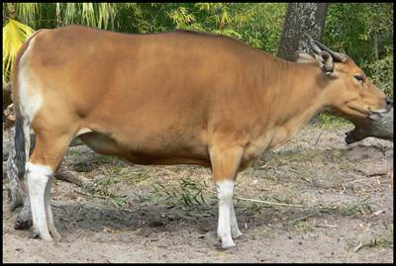 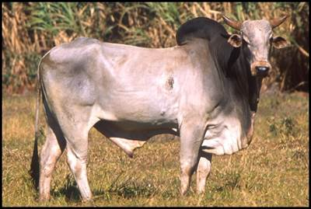  © 2006 Raul654. CC BY-SA 3.0 Unported.
40 | bull
41 | cow |  | If the language has terms for a pregnant cow and/or a lactating cow, please add an annotation here or explain under Part II.
42 | calf
43 | deer  rusa |  | Across Sulawesi there is only one type of deer, the introduced Javan deer, Rusa timorensis. Although the Indonesian terms rusa and kijang both get translated into English as ‘deer,’ the latter term technically refers to muntjacs (genus Muntiacus) as found on Kalimantan, Sumatra and elsewhere.  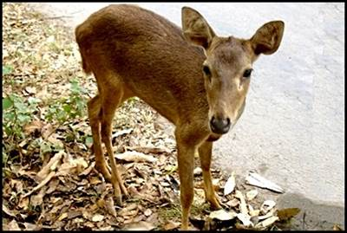 < fawn  More images: http://www.arkive.org/javan-rusa/rusa-timorensis/
44 | male deer, stag, buck
45 | female deer, doe, hind
46 | young deer, fawn
47 | cuscus, marsupial |  | Most Sulawesi languages have distinct terms for the bear cuscus versus the dwarf cuscus. If this is the case, report on lines 56 and 60, and leave this line blank. Conversely, be alert to the possibility that people may subdivide cuscuses further, as people may have local knowledge of cuscus species that have yet to be identified scientifically.
48 | bear cuscus |  | Phalanger ursinus. Diurnal, leaf-eating. In Sulawesi, this animal often goes by the name kusai, kuse or some similar term.  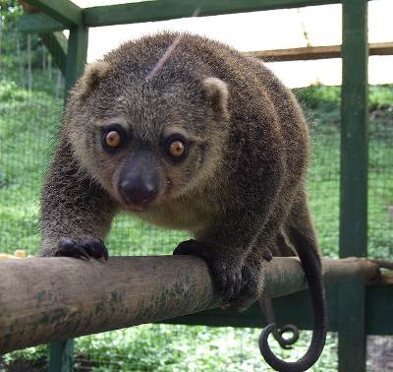  © 2008 Sakurai Midori. CC BY-SA 2.1 Japan.  More images: http://www.arkive.org/bear-cuscus/ailurops-ursinus/
49 | male bear cuscus
50 | female bear cuscus
51 | young bear cuscus
52 | dwarf cuscus  kuskus sulawesi |  | Stigocuscus celebensis. Nocturnal, fruit-eating.  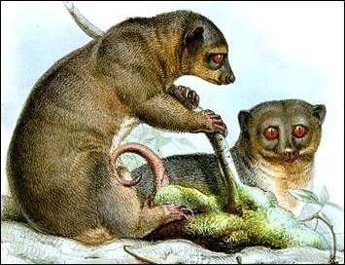  See more images here:  http://theoallofs.photoshelter.com/image/I0000fjlnNRn2xUw  http://fineartamerica.com/art/all/strigocuscus+celebensis/framed+prints
53 | male dwarf cuscus
54 | female dwarf cuscus
55 | young dwarf cuscus
56 | civet  musang |  | A civet is a cat-like carnivore, whose diet includes small mammals, birds and fruit. Three species are found on Sulawesi. If the language has only one term for civet and does not distinguish between species, or you do not know which species it refers to, enter that term here.
57 | male civet
58 | female civet
59 | young civet
60 | palm civet  musang biasa |  | Paradoxurus hermaphroditus. The palm civet has a pattern of longitudinal stripes on the back and spots on the shoulders, sides and thighs, especially in a new coat. There may be white patches on the head and a broad white patch across the forehead. Tail is long and bushy.  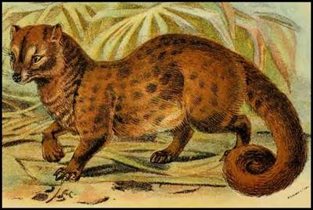  More images: http://www.arkive.org/common-palm-civet/paradoxurus-hermaphroditus/
61 | male palm civet
62 | female palm civet
63 | young palm civet
64 | brown palm civet, Sulawesi civet  musang sulawesi |  | Macrogalidia musschenbroekii. The coat of the Sulawesi civet is brown along the back and yellowish brown on the belly. The tail rings are indistinct, yellowish, and irregularly spaced, with some incomplete. Females may have seven rings and males eleven. The face has indistinct zones of paler-colored fur above and below the eyes. This animal is endemic to Sulawesi. It is rarely seen, and one of the world’s least-known carnivores.  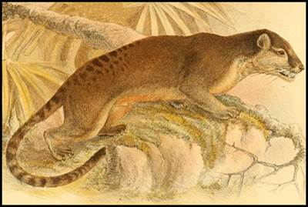  More images: http://www.arkive.org/sulawesi-palm-civet/macrogalidia-musschenbroekii/
65 | male Sulawesi civet
66 | female Sulawesi civet
67 | young Sulawesi civet
68 | Malay civet  tenggalong, tangalung |  | Viverra tangalunga. Fur of the neck is distinctively marked with usually three black and white striped collars. Underparts of the Malay civet are colored white, and the flank is patterned with black spots on a greyish tawny ground color The dorsal crest of erectile hairs is marked by a black stripe which runs from its shoulders to its tail. The tail is ringed with about 15 black and white stripes.  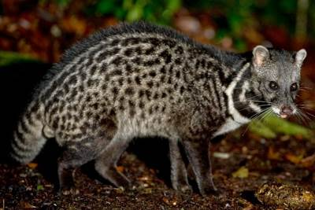  © 2010 Kalyan Varma. CC BY-SA 4.0 International.  More images: http://www.arkive.org/malay-civet/viverra-tangalunga/
69 | male Malay civet
70 | female Malay civet
71 | young Malay civet
72 | tarsier  ingkir |  | Tarsius spp. Tarsiers are small primates with long, thin, tufted tails and large eyes for hunting insects at night. Sulawesi may be home to two lowland species (T. dianae and T. spectrum) and a third species (T. pumilus) found at high altitudes. Kamus Besar (KBBI) supports the name ingkar, but other names include tangkasi, singapuar, tarsius, and binatang hantu.  “The tarsier social unit comprises an adult pair, which forms a stable, long-term monogamous relationship, together with their one or two immature offspring. They all sleep together in a tree hole within a more or less permanent territory… Every morning, just before these nocturnal animals retire to their nest, the entire family sings a complicated territorial call.”  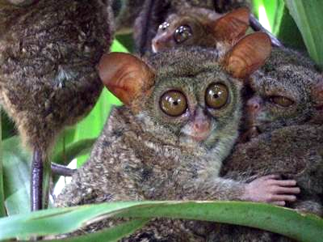  © 2008 Sakurai Midori. CC-BY-SA 2.1 Japan.
73 | male tarsier
74 | female tarsier
75 | young tarsier
76 | macaque  makaka |  | Despite their lack of prehensile tails, macaques (Macaca spp.) are monkeys, not apes. Sulawesi is home to between five and seven species of macaques. In general their respective ranges do not or only slightly overlap, but people living in transition zones could have different names for the two populations. Please add an annotation if you think this could be the case. Pictured below are a crested macaque (Macaca nigra) from North Sulawesi and a booted macaque (Macaca ochreata) from Southeast Sulawesi.  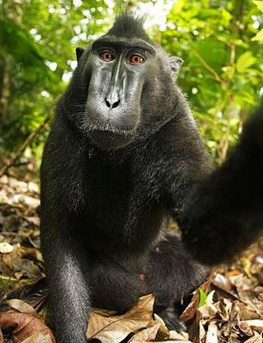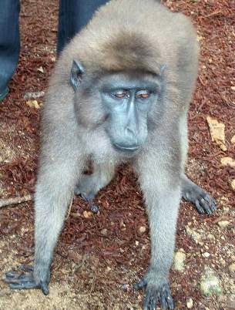
77 | male macaque
78 | female macaque
79 | young macaque
80 | horse  kuda |  | Equus caballus.  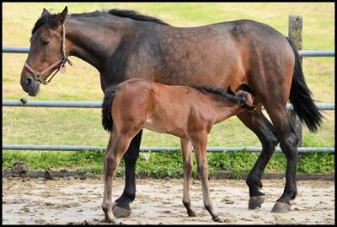
81 | stallion
82 | mare
83 | foal
84 | goat  kambing |  | Capra hircus.  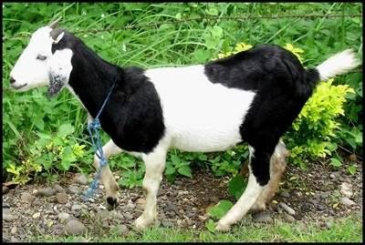
85 | male goat, buck, billy, ram
86 | female goat, doe, nanny
87 | young goat, kid
88 | dog  anjing |  | Canis familiaris.  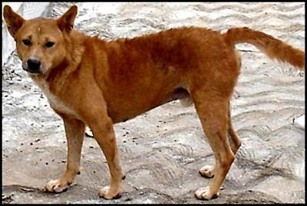
89 | male dog
90 | female dog
91 | puppy
92 | cat  kucing |  | Felis catus.  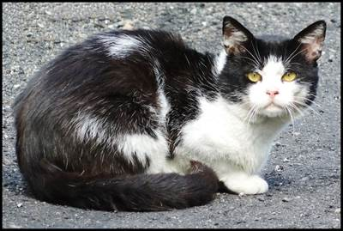
93 | male cat
94 | female cat
95 | kitten
96 | rat, mouse  tikus |  | Rats living with humans are rarely found in forests, conversely forest rats are not found beyond the forest edge. Some rats of Sulawesi are mainly arboreal. Pictured below are the house rat, Rattus rattus, and the house mouse, Mus musculus.  Around fifty species of rats have been identified from across Sulawesi. In places where rats are eaten (e.g. North Sulawesi), people may have greater awareness of different species. If people have names for different kinds of rats, please add an annotation including what, according to local opinion, are the major distinguishing characteristics, e.g. size, color, habitat.  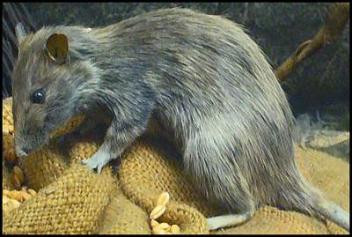 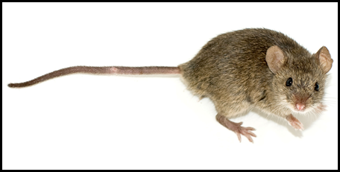  © 2009 H. Zell. CC BY 3.0 Unported. © 2008 George Shuklin. CC BY-SA 1.0 Generic.
97 | male rat
98 | female rat
99 | young rat, rat pup
100 | shrew  celurut |  | Some Sulawesi languages have a distinct name for shrews (versus rats and mice). The species most likely to be encountered is the Asian house shrew, Suncus murinus, pictured below. Other names by which shrews are known in Indonesian include tikus kesturi, tikus curut, cecurut, cencurut and munggis.  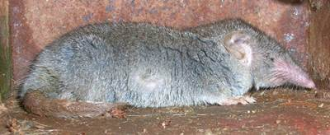  © 2005 L. Shyamal. CC BY-SA 2.5 Generic.
101 | squirrel  bajing |  | Sulawesi is home to twelve species of squirrels, although in any locale four or fewer species are likely to be present. One widely distributed species, including offshore islands, is the plaintain squirrel (bajing kelapa), Callosciurus notatus, pictured below.  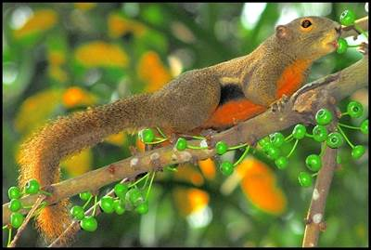  © 2006 Jwee, CC-BY 2.0 Generic
102 | male squirrel
103 | female squirrel
104 | young squirrel
105 | giant squirrel  bajing besar |  | Rubrisciurus rubriventer. A brownish red squirrel with a reddish-orange underside, it is the largest of Sulawesi’s squirrels and widely distributed across the island. It nests in tree hollows only a few feet off the ground. In some areas of its range people hunt it with dogs. (If you have an image of this squirrel, please share it with us.)
106 | dwarf squirrel  bajing kerdil |  | There are indications that some languages of Sulawesi may have a distinct name for the Sulwesi pygmy squirrel, Prosciurillus murinus, the smallest and most widely distributed of Sulawesi’s dwarf squirrels. Coat color is dark olive brown.  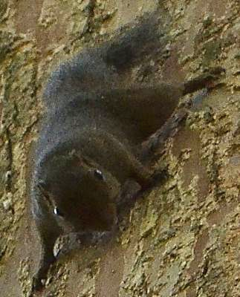  © 2012 Arifrahman, CC BY-SA 3.0 Unported.
107 | ground squirrel  bajing moncong panjang |  | Hyosciurus spp. Sulawesi ground squirrels, also known as long-nosed squirrels, are distinguished by their long snouts, relatively long straight claws, short tails (only fifty to seventy percent of head and body length), and their long and slender (rather than sturdy) hind feet. Two species have been described, but distribution requires further investigation. (If you have an image of a Sulawesi ground squirrel, please share it with us.)
108 | bat  kelelawar |  | Small, insect-eating bat. See picture below of a lesser sheath-tailed bat (Emballonura monticola), one of some forty species present on Sulawesi. The faces of the insectivorous bats are distinctively different, and it is possible that (some of) these may be known by name.  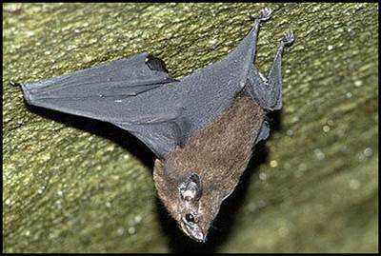  Image by Nick Baker, www.ecologyasia.com. Used with permission.
109 | male bat
110 | female bat
111 | young bat
112 | fruit bat  keluang, kalong |  | Most Sulawesi languages have a distinct lexeme for large, fruit-eating bats. See picture below of a striped-face fruit bat (Styloctenium wallacei), one of around two dozen species of fruit bat / flying fox found on Sulawesi. In areas where fruit bats are hunted and sold commercially, hunters may have distinct names and know how to differentiate among species.  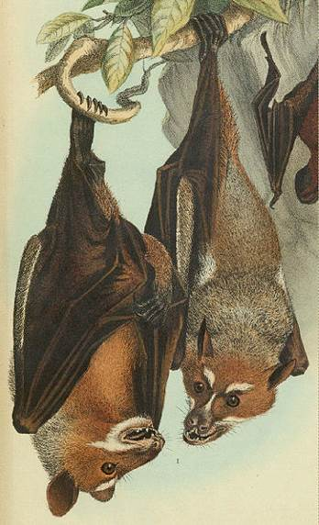
113 | male fruit bat
114 | female fruit bat
115 | young fruit bat
116 | rabbit  kelinci |  | Oryctolagus cuniculus. Introduced. In the 1980s the Indonesian government began promoting rabbits as a meat-producing livestock, and rabbit farming has grown in popularity particularly over the past decade. (Note: a type of striped rabbit is endemic to Sumatra, so it is possible that knowledge of rabbits in the Malay context could be of some antiquity.)  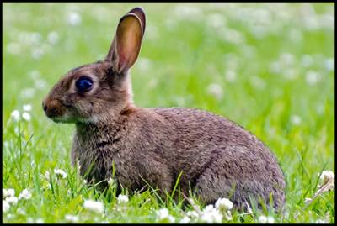
117 | male rabbit, buck
118 | female rabbit, doe
119 | young rabbit, kit
120 | guinea pig  tikus belanda |  | Cavia porcellus. Introduced as a pet. Colloquially sometimes called marmot or marmut in Indonesian, although this term technically applies to a different animal.  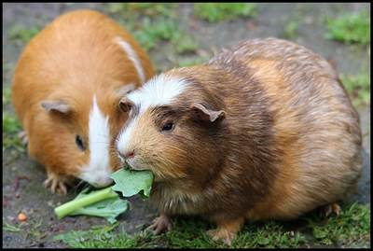
121 | male guinea pig
122 | female guinea pig
123 | young guinea pig
124 | porcupine  landak |  | The Sunda porcupine (Hystrix javanica) has probably been introduced into parts of Sulawesi.  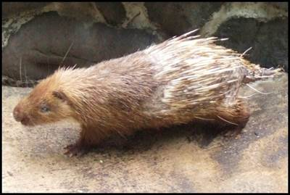
125 | male porcupine
126 | female porcupine
127 | young porcupine
128 | dugong  ikan duyung |  | Dugong dugon. Not a manatee, which are New World species.  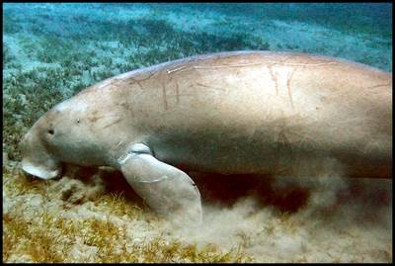  © 2004 Mark Goodchild CC BY 2.0 Generic.
129 | male dugong
130 | female dugong
131 | young dugong
132 | dolphin  ikan lumba-lumba |  | Several dolphin species have a pan-tropical distribution including Indonesia, among others the bottlenose dolphin, the short-beaked common dolphin, and the striped dolphin.  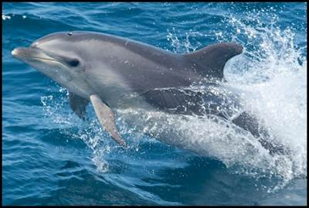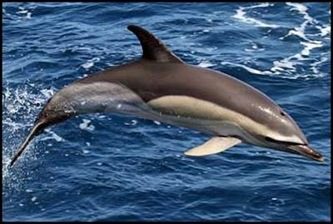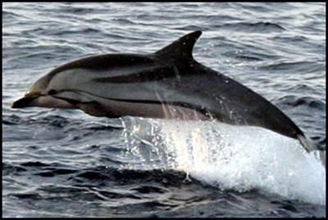
133 | male dolphin
134 | female dolphin
135 | dolphin calf
136 | whale  ikan paus |  | Several species of whales inhabit Indonesian waters. See picture below of a breaching humpback whale, Megaptera novaeangliae.  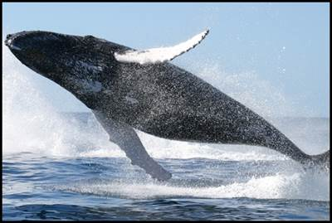
137 | male whale
138 | female whale
139 | whale calf
140 | data providers |  | People in the local community who have helped with this survey, and who allow their names to be publicly acknowledged.
141 | orthography / transcription |  | Please provide notes about any symbols or digraphs that differ from standard Indonesian or that in other ways may have an ambiguous usage.
142 | date |  | Date this survey was completed.
143 | email |  | Please include an email address if it is okay to contact you with any follow-up questions that we may have.

Part II: Additional Information
If you would like to share information in regard to any of the following questions, we would be glad to receive your responses.
1. Does the language have distinct terms for animals based on stage of maturation? Is there a different word for the young of the animal? Or even more specifically, for neonate, juvenile and sub-adult? Is there a special term for a particularly large animal of its kind (male or female)? For bovines and pigs, are there different terms for a female that has not yet given birth / has given birth / is past giving birth? A pregnant female and a lactating female? For babirusa and pigs, are there different words related to the length of the canines? For deer, are there names related to the size of the horns or their shape / number of points?
2. For social animals, is there a name for an individual that lives solitarily, apart from the group?
3. Within the species, are there names/descriptive terms for individuals with special coat coloring? For albinos?
4. Biologists have debated how many species of anoa should be recognized. If local people distinguish different types of anoa, what, according to local opinion, are the major distinguishing characteristics of each type?
5. Do people know of a of gliding mammal, which they may describe as a ‘tupai terbang’ or similar? Details would be important, since Sulawesi is reportedly without any kind of gliding mammal, squirrel or otherwise.
6. Are populations of wild (feral) dogs or cats known in the area? How do people refer to them in distinction to the domesticated animals?
7. Is the animal hunted (note: many species are actually protected by law)? If so, using what kind of methods, weapons, gear and/or traps? How are the different parts of the body (fur, skin, meat, horns, bones, teeth, innards, tail, etc.) used? Are any parts kept as trophies?
8. In particular do people know of harvesting musk/‘perfume’ from civets or cuscuses? What is the local word for this substance?
9. Apart from hunting, what purpose does the animal serve in the human sphere (e.g. draft animal, farmed for profit)? What tasks is it trained to perform? Is it kept as pet? Given pet names? Ever referred to in endearing terms?
10. Is animal sacrifice still practiced or remembered (e.g. eighty years ago dogs were still being sacrificed in parts of Sulawesi)? When, by whom and for what purpose?
11. What are community standards for how to treat animals? Conversely, what would constitute cruel behavior?
12. Are there different terms for the raw or cooked meat of these animals (e.g. pork, ham, beef, mutton, venison)?
13. How are the animals depicted in folktales? In particular if you know of any folktales involving the babirusa, please include an English translation of the story. Are there mammals not found on Sulawesi, that nonetheless have made their way into folktales in the local language?
14. How are the animals depicted in art or symbolic decoration? Is there knowledge of animal tattoos on people now or in the past? (For example, the canine teeth of babirusa, or their representations, performed such a role around a hundred years ago.)
15. Do clans identify with, trace their ancestry to, or have mythic beliefs about animal totems? Can an individual have a personal animal totem?
16. Are there words or expressions that people use to refer to an animal so as to avoid naming it directly (e.g. ‘flat butt’ for the macaque, ‘wide foot’ for the water buffalo)? Under what circumstances are replacement terms used (e.g. during rice harvest season, while hunting, while traversing certain locales)? What might result from failing to properly use a replacement term? Are replacement terms still actively used in the present day? What are the specific replacement terms for each animal (and their meanings) that people use or can remember from the past?
17. Besides naming an animal directly, are there other taboos involving mammals (e.g. never laugh at a beast, never hit a rat, never kill a cat)? What consequences might result otherwise?
18. Are any animals endowed with mystical or special powers? Does sighting or coming across a particular animal have special meaning?
19. Is there a kind of forest creature that supposedly exists, but no one has ever seen? (Note: there may be tales of animals that have not yet been scientifically described, or not described for that locality. No matter how odd or unbelievable, there may be clues remaining in the local languages and knowledge of people!)
Part III: Additional Questions
We are not seeking responses to any of the questions in this section, but you may wish to follow up on them for purposes of your own lexicographical research.
What sounds does the animal make?
What sounds are used to call the animal? To shoo it away?
Are there verbs describing characteristic actions performed by the animal?
What are the parts of each animal? Are there parts that have special names, e.g. the withers of a horse, the cloven hooves of a bovine, the wattle of a goat, the snout of a pig, the rump patch of a macaque, the marsupium (pouch) of a cuscus, the blowhole of a cetacean, to name just a few?

